Shading

📘 Definition
# Source: AI Source: Provided by: [Data Path: Persons Table -> ID Column: 1, Name_En Column: Motasem Essam] -> From: [ChatGPT] on [5/2/2026]
Shading is the process of adding light and dark variations to an object to make it look 3D, realistic, and detailed instead of flat.
It shows how light interacts with a surface.

💡 How shading works
# Source: AI Source: Provided by: [Data Path: Persons Table -> ID Column: 1, Name_En Column: Motasem Essam] -> From: [ChatGPT] on [5/2/2026]
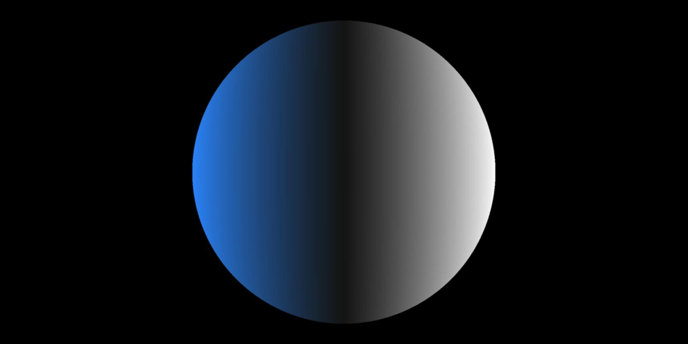
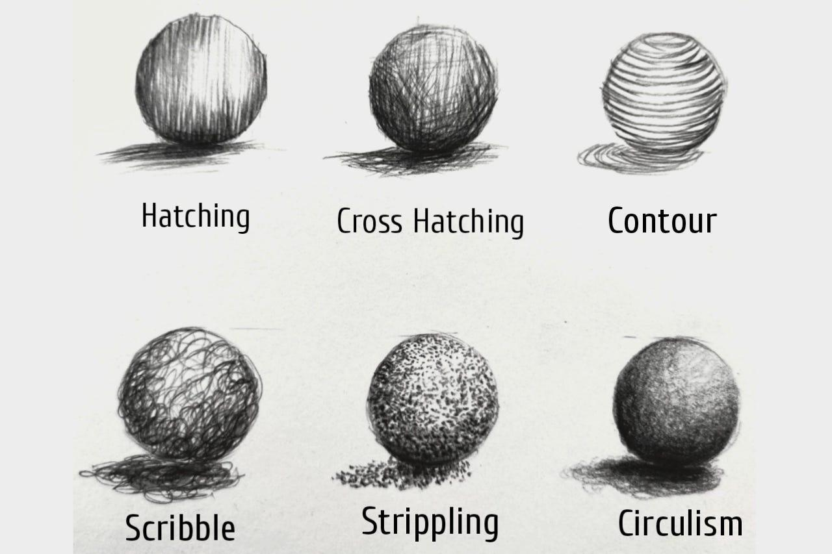
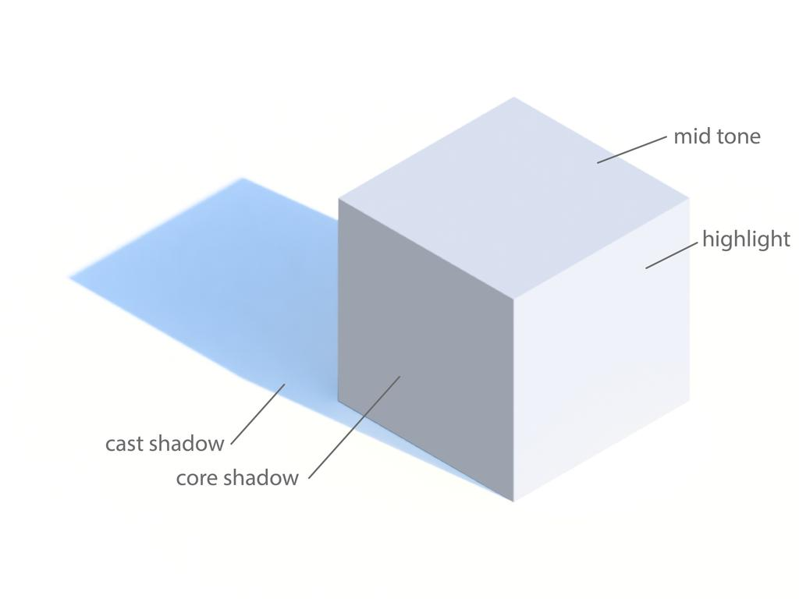
- Light hits an object
- Some areas become bright (light side)
- Some areas become dark (shadow side)
- The smooth change between them is shading

🧠 Simple example
# Source: AI Source: Provided by: [Data Path: Persons Table -> ID Column: 1, Name_En Column: Motasem Essam] -> From: [ChatGPT] on [5/2/2026]
Think of:
- ⚽ A ball under a lamp
  - One side is bright
  - One side is dark
  - The smooth transition between them = shading

🎮 Shading in computer graphics
# Source: AI Source: Provided by: [Data Path: Persons Table -> ID Column: 1, Name_En Column: Motasem Essam] -> From: [ChatGPT] on [5/2/2026]
Shading is used to:
- Make objects look 3D instead of flat
- Show light direction and depth
- Add realism in games, movies, and animations
- Improve materials like metal, skin, wood, etc.

🎨 Types of shading (basic idea)
# Source: AI Source: Provided by: [Data Path: Persons Table -> ID Column: 1, Name_En Column: Motasem Essam] -> From: [ChatGPT] on [5/2/2026]
- 🌕 Flat shading → one color per surface
- 🌗 Smooth shading → gradual light transition
- ✨ Phong/Lambert shading → realistic lighting models

⚙️ Key features
# Source: AI Source: Provided by: [Data Path: Persons Table -> ID Column: 1, Name_En Column: Motasem Essam] -> From: [ChatGPT] on [5/2/2026]
- 🎨 Combines light and dark areas
- 📏 Shows shape and depth
- 💡 Depends on light source direction
- 🧩 Essential for realistic graphics

🚀 In short:
# Source: AI Source: Provided by: [Data Path: Persons Table -> ID Column: 1, Name_En Column: Motasem Essam] -> From: [ChatGPT] on [5/2/2026]
Shading = adding light and dark areas to an object to make it look 3D and realistic.

